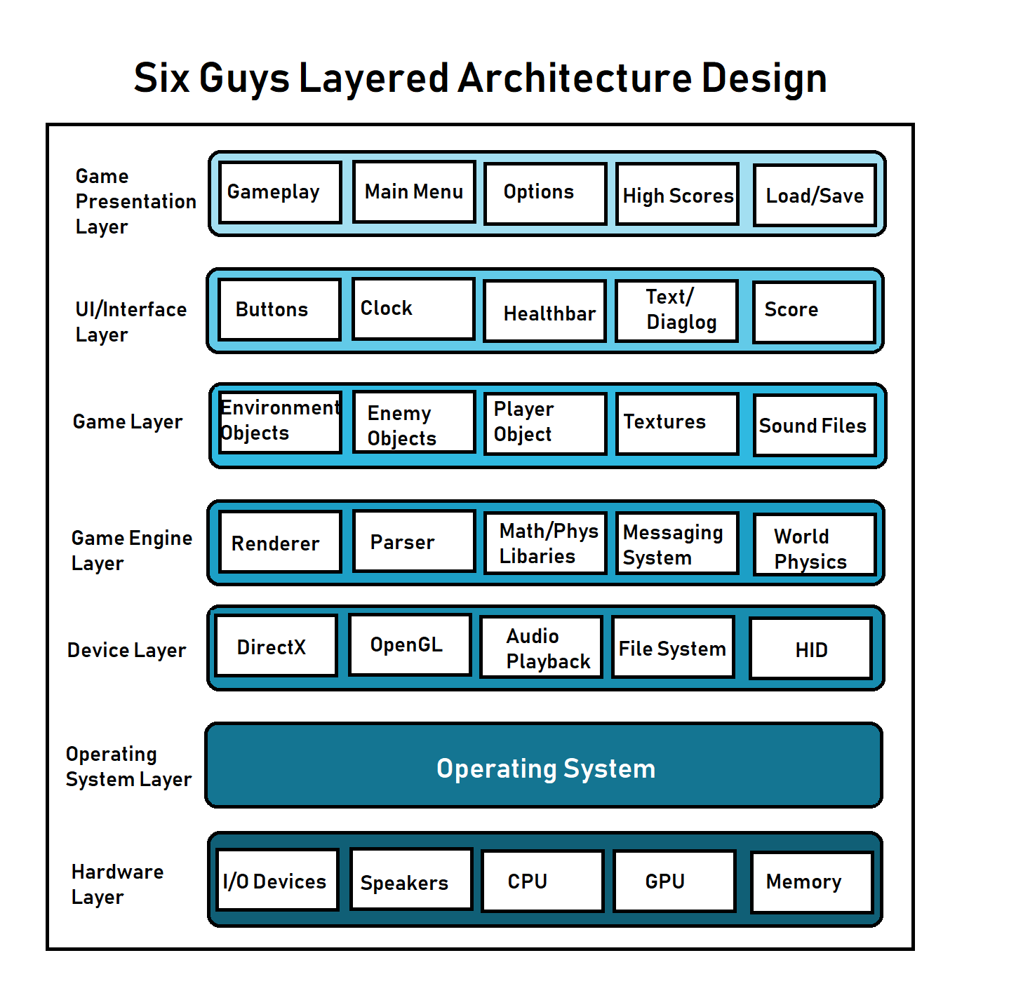

The software architecture design best suited for Six Guys Burger game is a layered architecture design. This model best describes this standalone application which involves many layers of the application itself and the system down to the hardware level. This is also the intuitive choice because the layers of the architecture of the design become quite apparent in the process of developing the game, if one considers the fact that first we are working off of the foundation of the Unity Engine creating our own scripts and objects within. Unity Engine itself works off the foundation of the OS, which is rooted in the hardware of the machine running it. The aspects of the game which we have devised also demonstrate layers, as there is the interface which the player interacts with in playing the game, but behind what the player is aware of are the logical calculations being performed by game application nonstop as they play.

In our model, the topmost layer is the Game Presentation Layer. This layer is composed with the elements, or the groups of elements which comprise of distinct gameplay elements which make up the essence of our game. These elements are formed in the layer below, the UI/Interface Layer, which is the visual elements of the game which the player interacts with and views in order to enjoy the game fully. The next layer is the aspect of the game hidden to the player which is the main area we have worked in the making of this game, which is the Game Layer. The Game Layer is composed of elements such as scripts for the player object, enemies and environmental objects/hazards, as well as textures, sounds and other more atomic game files. The next layer down is the Game Engine Layer, which are the components of Unity Engine utilized in our game. The components include the graphics and physics renderer, the parser for the C# scripts from the layer above, the libraries, messaging system, world physics and development UI, and so this layer is the project’s workstation. Finally there is the operating system layer, and lastly the Hardware Layer which are the hardware components such as the CPU, GPU, memory, speakers, and other I/O devices which make the operation of the game, and a PC in general, possible.